## **NAME: NIHARIKA AGRAWAL**

## **BATCH :4**

## **ROLL NO: R177219122**

## **SAPID: 500075359**

**EXPERIMENT-2**

**Title: 2. To understand and apply the concept of Constraints.**

**Objective:** To understand the concept of data constraints that is enforced on data being stored in the table. Focus on Primary Key and the Foreign Key.

**1. Create the tables described below:**

**Table name: CLIENT_MASTER_1**

**Description:** used to store client information.

|  |  |  |  |
| --- | --- | --- | --- |
| **Column name** | **data type** | **Size** | **Constraints** |
| CLIENTNO | Varchar | 6 | Primary key / first letter must start with ‘C’ |
| NAME | Varchar | 20 | Not Null |
| ADDRESS 1 | Varchar | 30 |  |
| ADDRESS 2 | Varchar | 30 |  |
| CITY | Varchar | 15 |  |
| PINCODE | Integer | 8 |  |
| STATE | Varchar | 15 |  |
| BALDUE | Decimal | 10,2 |  |

**Table Name: PRODUCT_MASTER_1 Description:** used to store product information

|  |  |  |  |
| --- | --- | --- | --- |
| **Column name** | **data type** | **Size** | **Attributes** |
| PRODUCTNO | Varchar | 6 | Primary Key/ first letter must start with ‘P’ |
| DESCRIPTION | Varchar | 15 | Not Null |
| PROFITPERCENT | Decimal | 4,2 | Not Null |
| UNIT MEASURE | Varchar | 10 | Not Null |
| QTYONHAND | Integer | 8 | Not Null |
| REORDERL VL | Integer | 8 | Not Null |
| SELLPRICE | Decimal | 8,2 | Not Null |
| COSTPRICE | Decimal | 8,2 | Not Null |

**Table Name: SALESMAN_MASTER _1**

**Description:**  used to store salesman information working for the company.

|  |  |  |  |
| --- | --- | --- | --- |
| **Column name** | **data type** | **Size** | **Attributes** |
| SALESMANNO | Varchar | 6 | Primary Key/ first letter must start with ‘S’ |
| SALESMANNAME | Varchar | 20 | Not Null |
| ADDRESS 1 | Varchar | 30 | Not Null |
| ADDRESS 2 | Varchar | 30 |  |
| CITY | Varchar | 20 |  |
| PINCODE | Integer | 8 |  |
| STATE | Varchar | 20 |  |
| SALAMT | Real | 8,2 | Not Null , Cannot be 0 |
| TGTTOGET | Decimal | 6,2 | Not Null , Cannot be 0 |
| YTDSALES | Double | 6,2 | Not Null |
| REMARKS | Varchar | 60 |  |

**2. Reinsert the data in these two tables based upon Lab 1.**

**3. Display the contents of each table.**

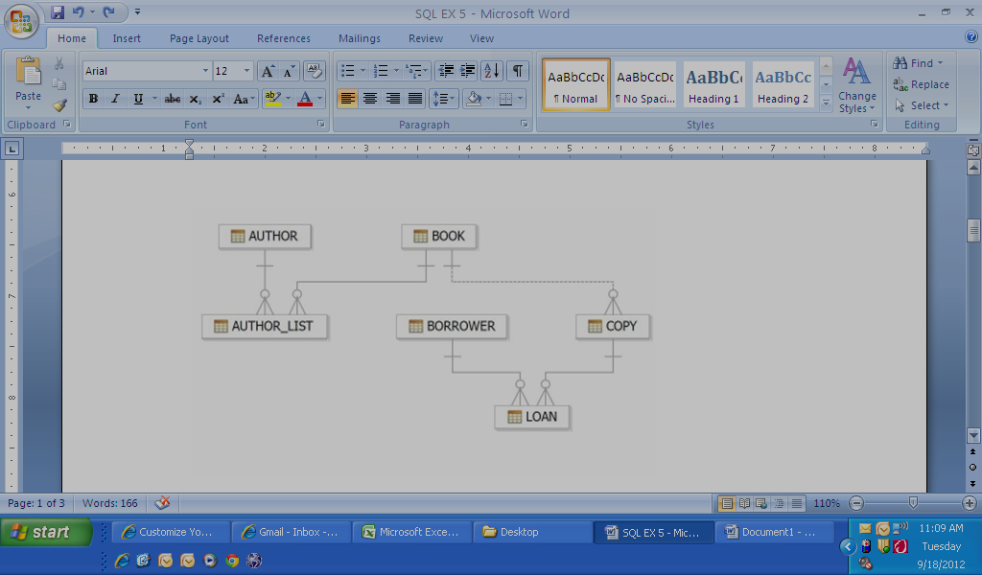

**4. Create table AUTHOR = {Author_ID , Lastname, Firstname, Email, City, Country}**

Where:

Author_ID – text data type, 5 characters, primary key

Lastname – text data type, 15 characters, not null

Firstname – text data type, 15 characters, not null

Email – text data type, 40 characters,

City – text data type, 15 characters,

Country – text data type, 15 characters,

**5. Create Table BOOK={ Book_ID, Book_Title, Copies)**

Where :

Book_ID – text data type, 5 characters Primary Key Start With Character **B**

Book_Title - Text data Type Not Null

Copies- No.of copies Data Type int always greater the 2

**6. Create table AUTHOR_LIST = {Author_ID , Book_ID , Role}**

Where:

Author_ID – text data type, 5 characters, referenced by Author_ID from AUTHOR

table

Book_ID – text data type, 5 characters

Role – text data type, 15 characters

and primary key is: Author_ID, Book_ID

**7. Add four records in each tables AUTHOR, BOOK, BOOK_LIST.**

**8. Alter structure of table AUTHOR_LIST add the field Publisher data type of 30 Character.**

## **ADBMS LAB EXPERIMENT – 2**

1. A)

Create table client_master_1(clientno varchar(6) check(clientno like ‘C%’)primary key,name varchar(20) not null,address_1 varchar(30),address_2 varchar(30),city varchar(15),pincode integer,state varchar(15),bal_due decimal(10,2));

OUTPUT

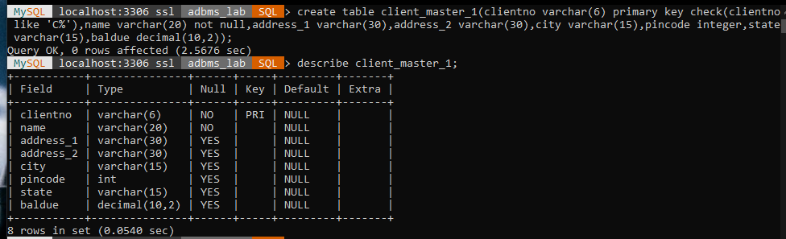

B)

create table product_master_1(productno varchar(6) primary key check(productno like 'P%'),description varchar(15) not null,profitpercent decimal(4,2) not null,unit_measure varchar(10) not null,qtyonhand integer not null,reorderl_vl integer not null,sellprice decimal(8,2) not null,costprice decimal(8,2) not null);

OUTPUT

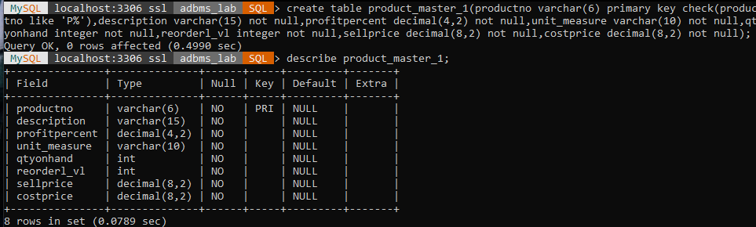

C)

create table salesman_master_1(salesmanno varchar(6) primary key check(salesmanno like 'S%'),salesmanname varchar(20) not null,address_1 varchar(30) not null,address_2 varchar(30),city varchar(20),pincode integer,state varchar(20),salamt decimal(8,2) not null check(salamt>0),tgttoget decimal(6,2) not null check(tgttoget>0),ytdsales decimal(6,2) not null,remarks varchar(60));

OUPUT

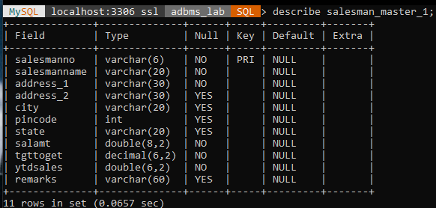

1. A)

insert into client_master_1 values('C00001','IVAN BAYROSS', ' ‘, ' ', 'MUMBAI',400054,'MAHARASHTRA',15000);

insert into client_master_1 values('C00002','MAMTA MUZUMDAR', ' ', ' ','MADRAS',780001,'TAMIL NADU',0);

insert into client_master_1 values('C00003','CHHAYA BANKAR', ' ', ' ', 'MUMBAI',400057,'MAHARASHTRA',5000);

insert into client_master_1 values('C00004','ASHWINI JOSHI', ' ', ' ','BANGALORE',560001,'KARNATAKA',0);

insert into client_master_1 values('C00005','HANSEL COLACO', ' ', ' ', 'MUMBAI',400057,' MAHARASHTRA', 2000);

insert into client_master_1 values('C00006','DEEPAK SHARMA', ' ', ' ', 'MANGALORE',560050,'KARNATAKA',0);

select * from client_master_1;

OUTPUT

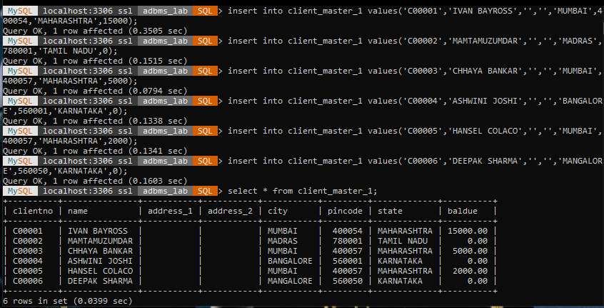

B)

insert into product_master_1 values('P00001','T-SHIRTS',5,'PIECE',200,50,350,250);

insert into product_master_1 values('P0345','SHIRTS',6,'PIECE',150,50,500,350);

insert into product_master_1 values('P06734','JEANS',5,'PIECE',100,20,750,500);

insert into product_master_1 values('P07868','TROUSERS',2,'PIECE',150,50,850,550);

insert into product_master_1 values('P07885','PULL OVERS',2.5,'PIECE',80,30,700,450);

insert into product_master_1 values('P07965','DENIM JEANS',4,'PIECE',100,40,350,250);

insert into product_master_1 values('P07975','LYCRA TOPS',5,'PIECE',70,30,300,175);

select * from product_master_1;

OUTPUT

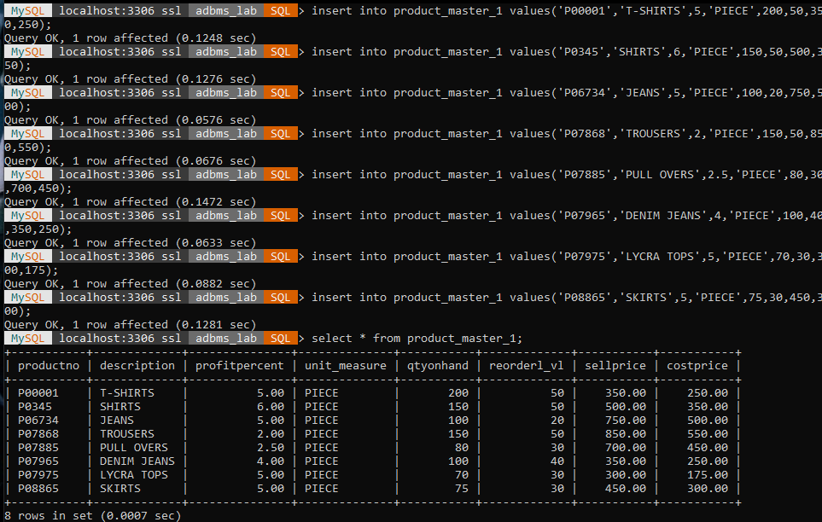

C)

insert into salesman_master_1 values('S00001','AMAN','A/14','WORLI','MUMBAI',400002,'MAHARASHTRA',350,500,1000,'');

insert into salesman_master_1 values('S00002','OMKAR','65','NARIMAN','MUMBAI',400001,'MAHARASHTRA',200,600,1200,'');

insert into salesman_master_1 values('S00003','RAJ','P-7','BANDRA','MUMBAI',400032,'MAHARASHTRA',400,700,8000,'');

insert into salesman_master_1 values('S00004','ASHISH','A/5','JUHU','MUMBAI',400044,'MAHARASHTRA',75,500,5000,'');

select * from salesman_master_1;

OUTPUT

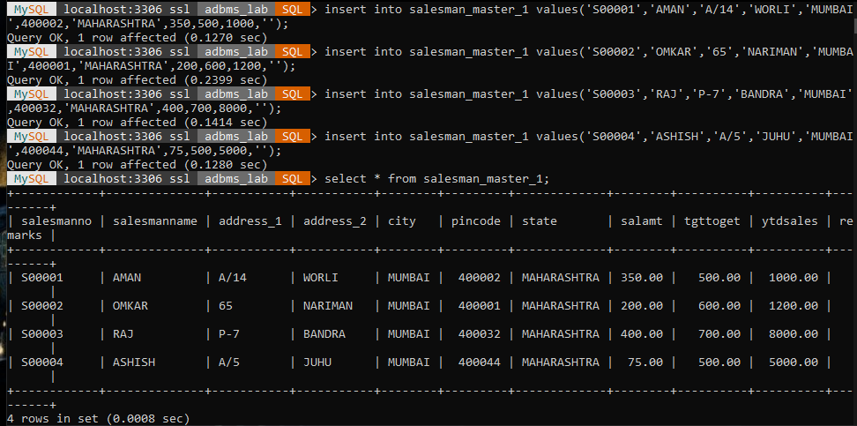

1. A)

select * from client_master_1;

OUTPUT

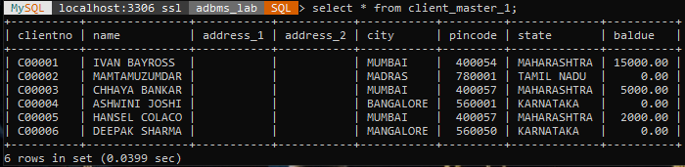

B)

select * from product_master_1;

OUTPUT

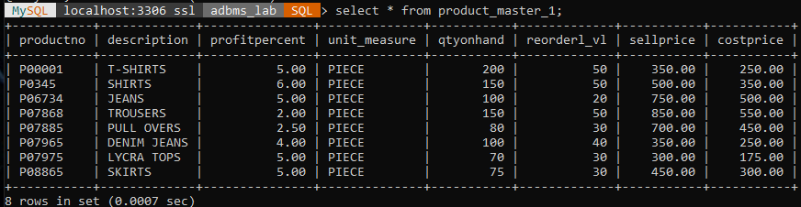

C)

select * from salesman_master_1;

OUTPUT

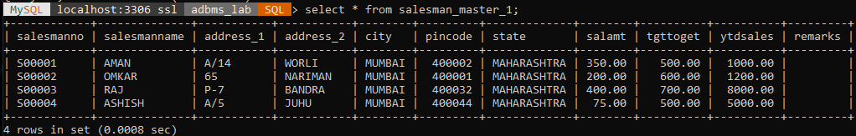

1. create table author(author_id varchar(5) primary key,lastname varchar(15) not null,firstname varchar(15) not null,email varchar(40),city varchar(15),country varchar(15));

describe author;

OUTPUT

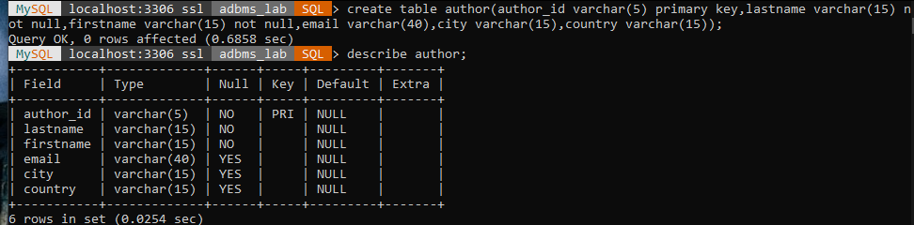

1. create table book(book_id varchar(5) primary key check(book_id like 'B%'),book_title varchar(30) not null,copies integer check(copies>2));

describe book;

OUTPUT

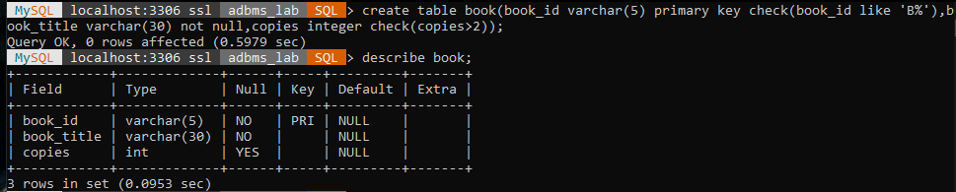

1. create table author_list(author_id varchar(5),foreign key(author_id)references author(author_id),book_id varchar(5),role varchar(15),primary key(author_id,book_id));

describe author_list;

OUTPUT

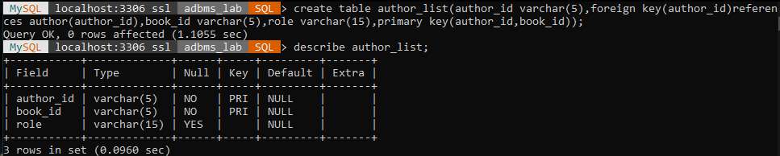

1. A)

insert into author values('A001','SHAKESPEARE','WILLIAM','','STRATFORD','ENGLAND');

insert into author values('A002','ROWLING','JOANNE','','KILLIECHASIE','SCOTLAND');

insert into author values('A003','MARTIN','GEORGE','','SANTA FE','USA');

insert into author values('A004','STINE','ROBERT','','COLUMBUS','USA');

select * from author;

OUTPUT

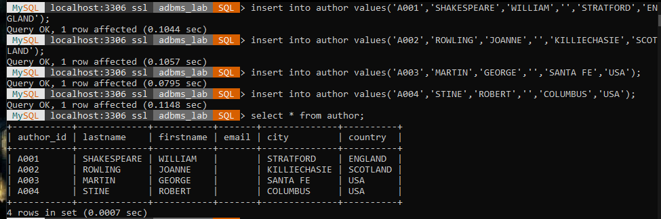

B)

insert into book values('B001','BOOK I-AIR',500);

insert into book values('B002','BOOK II-WATER',1000);

insert into book values('B003','BOOK III-EARTH',700);

insert into book values('B003','BOOK IV-FIRE',2000);

select * from book;

OUTPUT

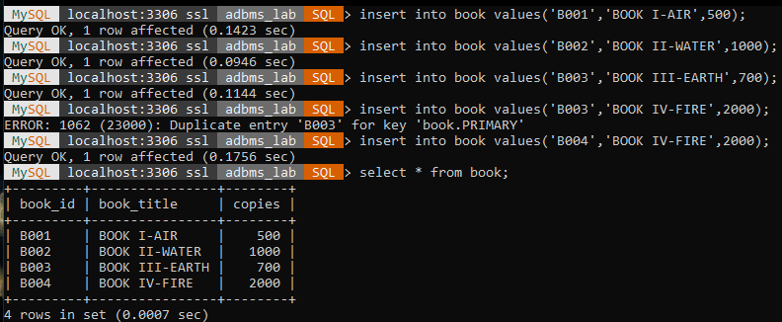

C)

insert into author_list values('A001','B001','READ');

insert into author_list values('A002','B002','READ');

insert into author_list values('A003','B003','READ');

insert into author_list values('A004','B004','READ');

select * from author_list;

OUTPUT

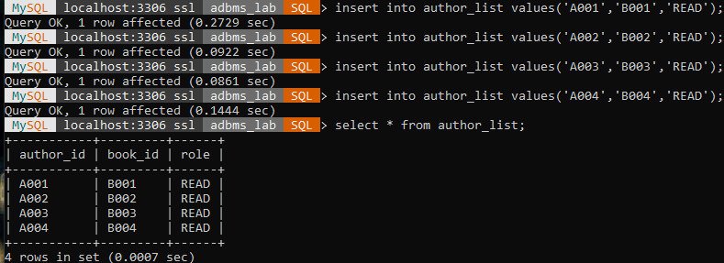

1. alter table author_list add publisher varchar(30);

describe author_list;

OUTPUT

